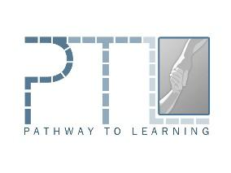
REGISTRATION FORM: INCLUSION 2019, COMMUNITY HUB CRAIGAVON

Name
Address
Email Address
Emergency Contact Number
Childs Name
Age and Date of Birth
School (must be attending mainstream) include details on 1:1
Date of ASD Diagnosis/ongoing assessment
Any other diagnosis?

Challenging Behaviour - give all details of challenging behaviour
Medical or Allergy needs - give details of all medical needs or if an allergy is present
Toilet Trained - give details of support needed around toileting

Form of Communication - give details of communication style – e.g verbal, PECS, Makaton etc

Home/community Support - give details of any support you have currently in place at home — list all therapies you currently use or have used in the past. For instance, ABA, speech therapy, OT.

Name two caregivers who will avail of the parent training and their relationship to your child.
Are you willing to travel to Craigavon each Saturday morning for the 6 weeks?
Photo/ Video Consent - photos may be used for future promotion of this course

Inclusion for ASD groups will occur for 6 consecutive Saturday’s (with a break for July 12th weekend) from 9.30-12. There will be a mid-morning break

Please circle dates you can attend (priority will be given to those families who can attend all 6 dates):

6th July | 20th July | 27th July
3rd August | 10th August | 17th August

